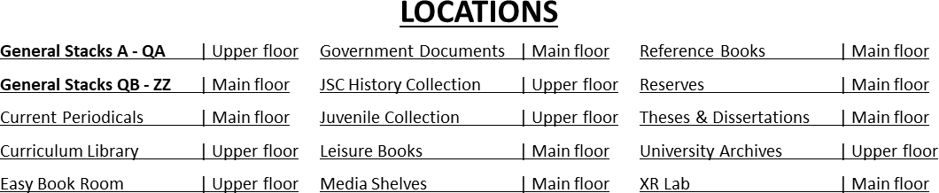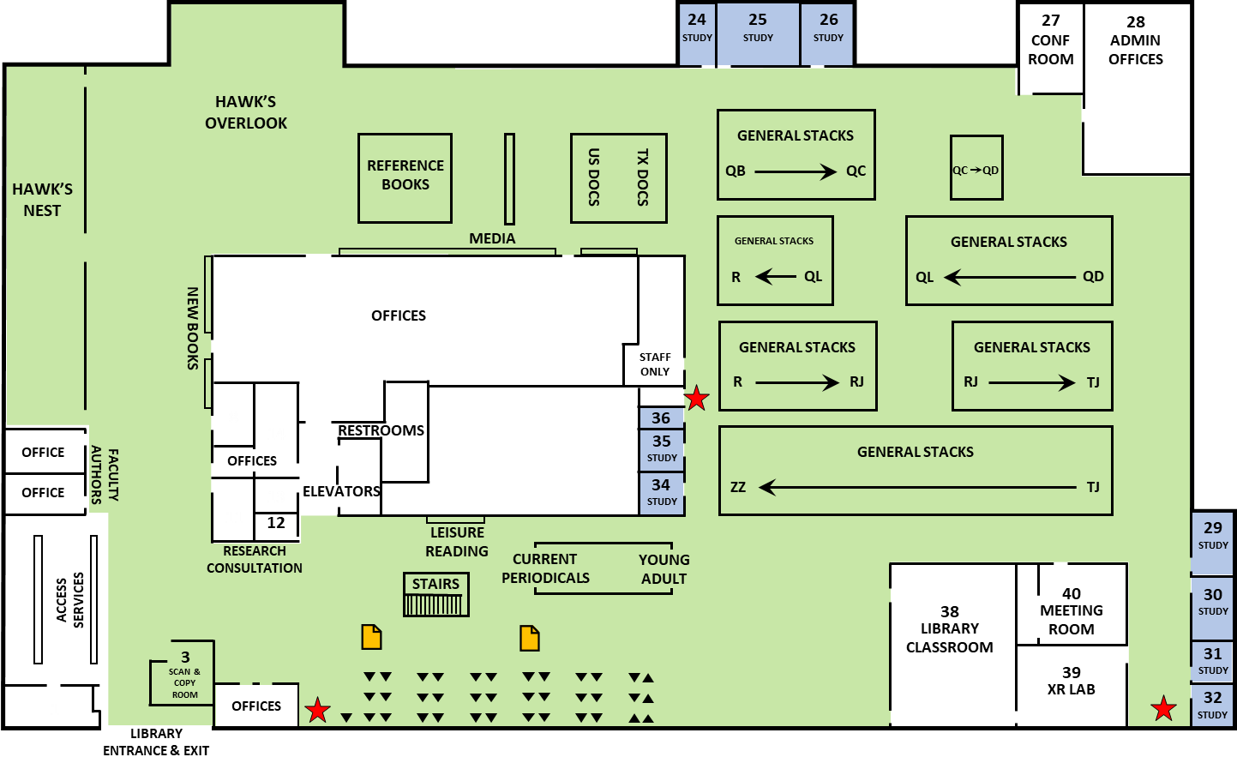MAIN FLOOR

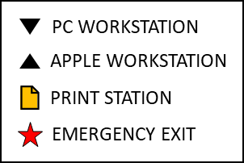
COLLABORATIVE ZONE
Main floor
QUIET ZONE
Upper floor
STUDY ROOM

UPPER FLOOR
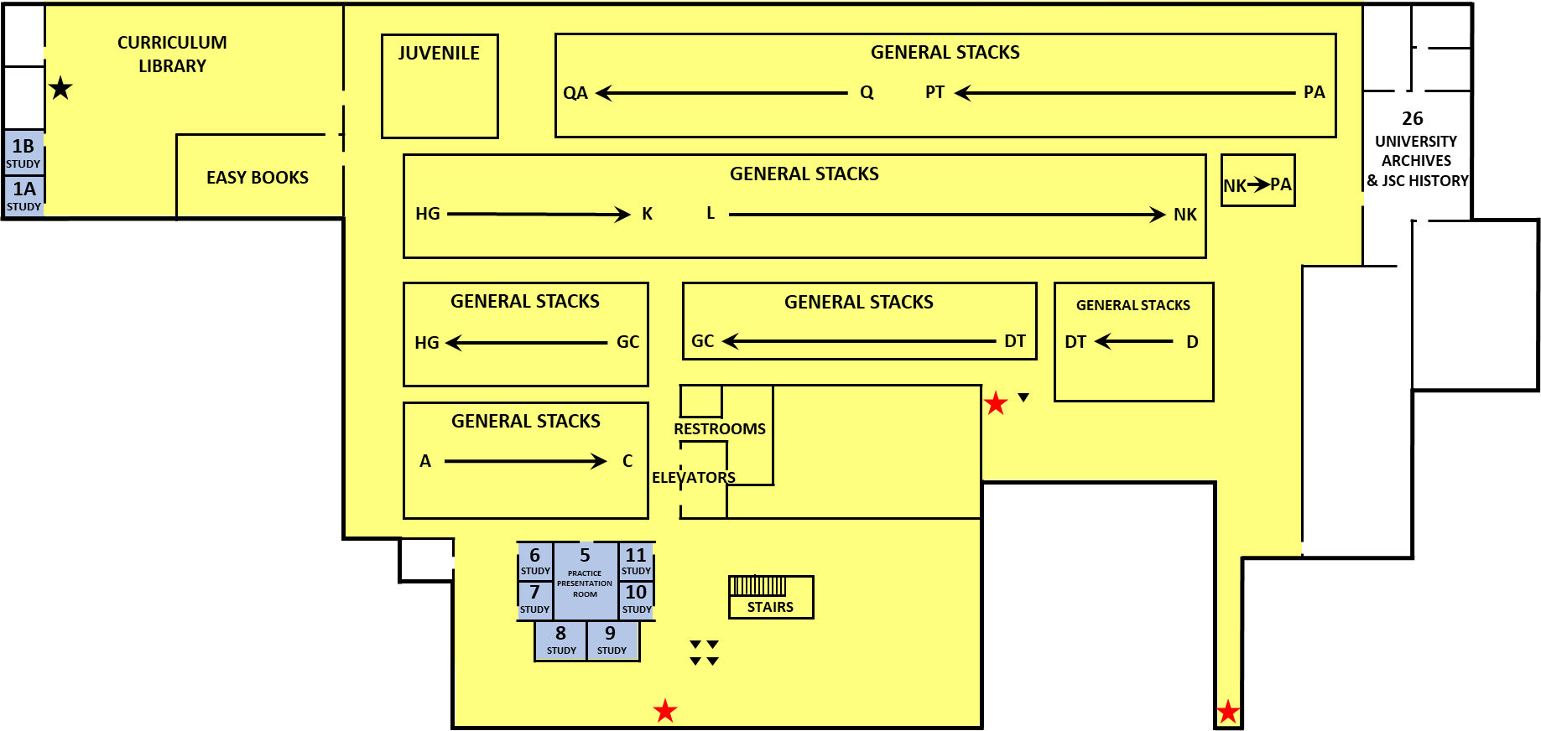


COLLABORATIVE ZONE
Main floor
QUIET ZONE
Upper floor
STUDY ROOM

