

Pandemic Influenza Plan

2019 - 2020

Record of Annual Plan Review

Date | Review facilitated by:

Record of Change

The changes implemented through the current year will be highlighted in the chart below. All other previous year changes will be kept on file in the Office of Emergency Management (OEM).

Date | Section | Description of Change | Entered by
3/03/20 | Throughout | Adapted from the University of Houston 2019-2020 Pandemic Influenza Plan for use at the University of Houston-Clear Lake campus. | A. Murillo

Table of Content
Record of Annual Plan Review 2
Record of Change 3
Section A – Authority, Purpose & Scope, Situation and Planning Assumptions 5
Authority 5
Purpose and Scope 5
Situation Overview 6
Planning Assumptions 8
Section B - Concept of Operations 10
UHCL Emergency Planning Structure 10
Actions by Phases of Emergency Management 12
Section C - Organization and Assignment of Responsibilities 14
Assignment of Responsibilities 14
Section D - Direction, Control and Coordination 19
Direction and Control 19
Emergency Operations Center 20
Decision Making Process 21
Coordination with the Public Health Authority 23
Coordination with the Texas Medical Center 24
Section E - Plan Development and Maintenance 24
Annual Plan Review 24
Plan Distribution 24
Section F - Authorities and References 25
References 25
Attachment 1 – UHCL Student Health Center Pandemic Influenza Disease Plan 26
Attachment 2 – Pandemic Stages 34
Attachment 3 – Pandemic Severity Index/Community Strategies 37
Attachment 4 – Emerging Health Issues Advisory Group 40

Section A – Authority, Purpose & Scope, Situation and Planning Assumptions

Authority

This plan has been approved by the Associate Vice President for Campus Safety and Security and was developed by the UHCL Office of Emergency Management (OEM) in the UHCL Police Department. During a response to pandemic influenza, the direction of local, state, or federal public health authority may alter the strategies that are outlined in this plan.

This plan falls under the authority outlined in the UHCL Emergency Management Plan (EMP) which outlines how any emergency is managed on the University of Houston-Clear Lake Campus. This emergency response planning is based on the National Incident Management System (NIMS), a standard model throughout the United States and the Incident Command System (ICS), the management structure adopted by first responders at UHCL. NIMS contains flexible and functional positions for each critical operation of the University during any emergency.

Purpose and Scope

The purpose of the University of Houston-Clear Lake Pandemic Influenza Plan is to provide guidance in preparing for, identifying, and responding to pandemic influenza that affects the University of Houston-Clear Lake. The objectives of this plan are to reduce the morbidity, mortality, and social and economic disruption caused by an outbreak of influenza on the students, staff, and faculty of the University of Houston-Clear Lake community. This plan provides a framework for pandemic influenza preparedness and response activities and serves as a foundation for further planning, drills, and emergency preparedness activities.

Pandemic influenza will pose unique and long-standing challenges not common to other disasters. The goal of pandemic influenza preparedness and response is to limit the spread of the virus; to minimize serious illness, hospitalizations, and death; to sustain critical infrastructure; and to minimize social disruption in Texas as a result of pandemic influenza.

The priorities of UHCL during a disaster are for the protection of lives, assets, valuable research processes, property, and the environment. The overall objective is to respond to emergency conditions and manage the process of restoring University academic, research programs and special services.

This plan is limited to preparedness and response for the UHCL campus. The Pandemic Influenza Plan serves to provide the basic structure and guidance to planning and coordinating, monitoring and assessment, prevention and control, UHCL Health Center response, communications, and public education.

It is important to note that while the plan focuses on influenza, it is also intended to serve as the template for responding to large-scale outbreaks of other highly infectious respiratory diseases, even if some prevention measures or response tactics may change due to the nature of a particular disease such as Severe Acute Respiratory Syndrome (SARS).

Situation Overview

A significant and recurring risk to the university is that of pandemic influenza. Influenza, also known as the flu, is a disease that infects the respiratory tract (nose, throat, and lungs). Influenza usually comes on suddenly and may include fever, headache, dry cough, sore throat, nasal congestion, and body aches. Although the seasonal flu is not usually fatal, complications can arise. As noted in the National Strategy for Pandemic Influenza Plan, the seasonal flu kills an average of 36,000 U.S. citizens every year, sends some 200,000 to the hospital, and causes countless lost days of school and work.

Pandemic influenza occurs when a novel influenza virus appears that causes readily transmissible human illness against which most people lack immunity. During the 20th century, there were three such pandemics, the most notable of which was the 1918 Spanish influenza responsible for 20 million deaths throughout the world. A new strain of influenza, resulting from antigenic drift, is the form of pandemic disease most likely to affect the University of Houston-Clear Lake.

The impact of an actual pandemic cannot be predicted precisely, as it will depend on the virulence of the virus, how rapidly it spreads, the availability of vaccines and antivirals, and the effectiveness of medical and non-medical containment measures. When pandemic influenza occurs, many people will become ill and may die from the virus or complications. One can only become immune to infection after natural infection or after receiving an effective vaccination. In addition, animals may also be susceptible to the novel influenza virus and may carry, spread, or serve as an intermediate host of the virus. Experts predict that a highly virulent strain of pandemic influenza would disrupt all aspects of society and severely affect the economy.

How does Seasonal Flu Differ from Pandemic Flu?

Seasonal Flu | Pandemic Flu
Happens annually and usually peaks between December and February | Rarely happens (three times in 20th century)
Usually some immunity built up from previous exposure and influenza vaccination | Most people have little or no immunity because they have no previous exposure to the virus or similar viruses
Certain people are at high-risk for serious complications (infants, elderly, pregnant women, extreme obesity and persons with certain chronic medical conditions) | Healthy people may be at increased risk for serious complications
Health care providers and hospitals can usually meet public and patient needs | Health care providers and hospitals may be overwhelmed. Alternate care sites may be available to meet public and patient needs.
Vaccine available for annual flu season. Usually, one dose of vaccine is needed for most people | Although the US government maintains a limited stockpile of pandemic vaccine, vaccine may not be available in the early stages of a pandemic  Two doses of vaccine may be needed.

Adequate supplies of antivirals are usually available | Antiviral supply may not be adequate to meet demand
Rates of medical visits, complications, hospitalizations and death can vary from low to high  CDC estimates that flu-related hospitalizations since 2010 ranged from 140,000 to 710,000, while flu-related deaths are estimated to have ranged from 12,000 to 56,000. | Rates of medical visits, complications, hospitalizations and death can range from moderate to high  Number of deaths could be much higher than seasonal flu (e.g. The estimated U.S. death toll during the 1918 pandemic was approximately 675,000)
Usually causes minor impact on the general public, some schools may close and sick people are encouraged to stay home  Manageable impact on domestic and world economies | May cause major impact on the general public, such as travel restrictions and school or business closings  Potential for severe impact on domestic and world economies
https://www.cdc.gov/flu/pandemic-resources/basics/about.html www.flu.gov

Planning Assumptions

- Seasonal influenza vaccination may or may not offer some level of protection against a novel pandemic influenza strain.
- It is highly unlikely that the most effective tool for mitigating a pandemic (a well-matched pandemic strain vaccine) will be available when a pandemic begins.
- The time from a candidate vaccine strain to the production of the first vaccine dosage could be six months or more.
- Once vaccine is available, it may take five months to produce an adequate supply of vaccine for the entire U.S. population (currently production capacity is approximately five million doses per week).
- Two doses of vaccine administered 30 days apart may be required to develop immunity to a novel virus.
- There is a limited supply of antiviral medications. Antiviral distribution to states will occur through the Strategic National Stockpile.

- Non-medical containment measures will be the principal means of disease control until adequate supplies of vaccines and/or antiviral medications are available.
- The novel influenza virus may initially be spread by animals to people in Texas, or by people entering the state and already contagious with the virus.
- Multiple waves of illness are likely to occur - each wave may last six to eight weeks.
- Pandemic influenza may severely affect even otherwise healthy individuals in all age groups, and will limit or degrade the response capabilities of all levels of government.
- Persons who become ill shed virus and may transmit virus up to one day previous to the onset of illness. Persons who are ill may shed virus up to five to seven days after onset of illness.
- Those exposed and infected with influenza exhibit symptoms in about two days, however could take anywhere between one and four days.
- Systematic application of disease control measures can significantly reduce the disease transmission rates with accompanying reductions in the intensity and velocity of pandemic influenza.
- Control and monitoring of pandemic influenza will involve many state and federal agencies, not just those associated with public health activities.
- Some individuals may not believe the reality of the threat posed by a pandemic influenza incident, and may take actions counterproductive to the government process to quarantine, control and treat infected people with the disease. Health education will be needed on multiple levels and at multiple points to achieve full cooperation.
- Over the course of the pandemic, up to 50 percent of the work force may be absent due to illness, caretaking responsibilities, fear of contagion, loss of public transportation, or public health control measures.
- The health impact of a pandemic event will be great. Up to 25-35% of persons may become ill in a major pandemic influenza. Rates of influenza-related hospitalizations and deaths may vary substantially from year to year. Estimates based on past pandemic influenza events indicate that 0.01-8% of the population may be hospitalized and 0.001-1% of the population may die.
- There will likely be critical shortages of health care resources such as pharmaceuticals, vaccine (once developed), staffed hospital beds, health care workers, mechanical ventilators, morgue capacity, and temporary refrigerated holding sites.

- Pandemic influenza will severely affect local and state economies, as well as intrastate, interstate, and international travel and commerce.
- Pandemic influenza may result in long-term and costly emergency response operations.
- Pandemic influenza may cause stress and/or emotional trauma.
- Disseminating timely, consistent, and accurate information to public and private sector stakeholders, the media, and the general public is one of the most critical facets of pandemic influenza preparedness and response.
- Individuals with the highest risk for serious influenza complications include; older people, young children and people with certain health conditions.

Section B - Concept of Operations

The University of Houston-Clear Lake conducts emergency response operations using the National Incident Management System (NIMS) and the Incident Command System (ICS) models. NIMS and ICS provide a consistent nationwide mechanism designed to assist all government, private sector, and nongovernmental organizations in working together during incidents when necessary. More information and education regarding NIMS and ICS can be found at the Federal Emergency Management Association’s (FEMA) Emergency Management Institute (EMI) website at http://training.fema.gov/EMI/.

The Governing Body of the UHCL Student Health Center (chaired by the Chief Physician) serves in a health advisory role for the university regarding pandemic influenza. This role includes interpreting guidance from public health authorities and recommending actions to be taken or implemented at the University of Houston-Clear Lake. The UHCL Student Health Center may review and seek guidance from local, state or other health authorities.

UHCL Emergency Planning Structure

The University of Houston-Clear Lake Pandemic Influenza Plan falls under the review by the Emergency Planning Committee. As such, a reference to the structures has been included for
information. As outlined in the University’s Emergency Management Policy (MAPP 01.F.05), the UHCL Emergency Planning Structure is comprised of the following three primary groups:
Executive Operations Team (EOT):
The Executive Operations Team (EOT) has the following roles in regard to emergency planning: policy approval, procedure analysis, compliance related matters, making recommendation to the University President regarding campus closure/cancellation of classes, as well as making recommendations to the University President regarding campus response/recovery efforts in the event of a campus-wide emergency. The Executive Operations Team (EOT) is responsible for the final approval of any major planning developments or changes created by the Emergency Planning Committee. The EOT is comprised of Vice Chancellors/Vice Presidents of the President’s Cabinet.

Emergency Planning Committee:
The purpose of the Emergency Planning Committee is to improve campus-wide emergency planning through campus-wide collaboration, coordination and the development of specific emergency procedures and processes. The Emergency Planning Committee is responsible for identifying areas within the university’s emergency operations that need improvement and lack coordination. In addition, the committee collaborates and participates in campus- wide emergency response and recovery planning in order to facilitate effective emergency operations. The committee includes representatives from various departments and divisions who are responsible for providing support and giving direction within their area of expertise, as well as, have a key role in emergency planning.

Emergency Planning Committee Subgroups and Workgroups:
The Emergency Planning Committee subgroups are developed to improve specific aspects of campus-wide emergency operations. These subgroups will be potentially made up of Committee members as well as outside members who play a specific role and provide technical expertise to assist in the planning and collaboration of the subgroup. These subgroups are responsible for developing the specific processes and procedures to improve emergency operations. Each subgroup will have a Chair or Project Manager who is responsible for reporting developments and plans to the overall Emergency Planning Committee.

The UHCL Emergency Planning Structure organizational layout is as follows:

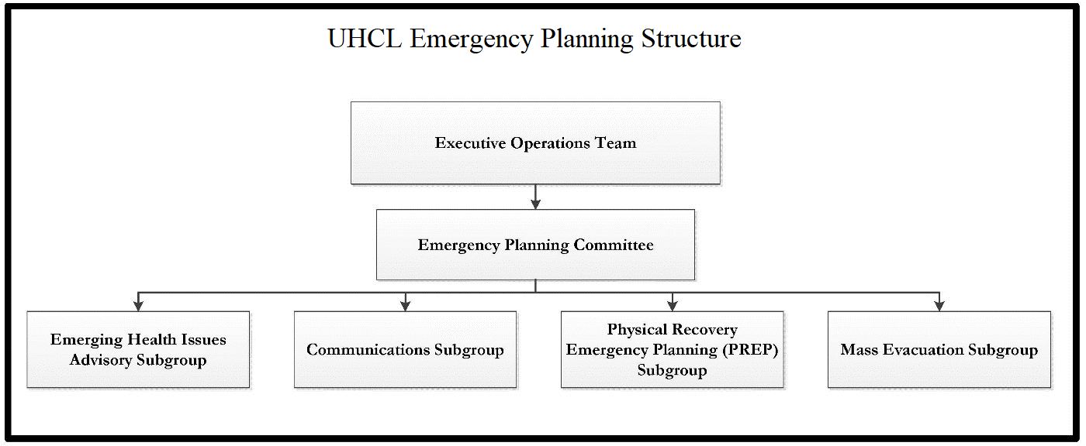

Emerging Health Issues Advisory (EHIA) Subgroup:
This advisory group was developed as a result of our pandemic influenza planning at the University of Houston-Clear Lake. The purpose of the board is to promote coordination across our university as well as with local public health authorities in the event of a health related emergency. In addition to the coordination, the advisory group will make recommendations to assist the university’s response.

Actions by Phases of Emergency Management
- Prevention/Mitigation:

  - Update and maintain the UHCL Pandemic Influenza Plan.

  - Collaborate with individual UHCL departments to create their own pandemic influenza response plan.

  - Promote seasonal flu vaccinations.

  - Promote protective measures like hand-washing and respiratory etiquette during flu season.

- Preparedness:

  - Educate students, faculty and staff regarding personal protection or mitigation strategies including seasonal influenza vaccination, respiratory etiquette, and responsible use of antiviral drugs.

  - Utilize pandemic influenza surveillance and testing at the UHCL Student Health Center.

  - Direct persons with flu-like symptoms to the UHCL Student Health Center for point of care testing for Influenza strains A and B.

  - Conduct training and awareness campaigns to educate students, staff and faculty on symptom recognition and infection control measures.

  - Develop and disseminate pandemic influenza related public information campaigns for travelers who may have visited potential pandemic influenza affected areas.

  - Ensure a communication system is established and maintained throughout a pandemic influenza response.

  - Conduct tabletop exercises to implement pandemic influenza plans and test response procedures.

  - The Emerging Health Issues Advisory (EHIA) Group will meet regularly to coordinate planning activities for pandemic influenza.

- Response

  - Activate the UHCL Emergency Operations Center (UHCLEOC), if necessary.

  - Continue enhanced communication and surveillance activities.

  - As available, distribute antiviral medications, vaccines and medical supplies to address UHCL needs.

  - Activate law enforcement entities to assist in pandemic influenza control measures and maintenance of social order.

  - Continue to educate citizens about personal protective strategies and population level interventions that may be initiated during a pandemic within their community.

  - Develop and disseminate public service announcements, utilizing University Marketing, Communications and Media Relations and the Joint Information Center (JIC), for release to the media concerning pandemic influenza outbreak.

  - The Emerging Health Issues Advisory (EHIA) Group will meet more often to coordinate response activities and determine recommendations related to the pandemic influenza emergency.

- Recovery

  - Obtain all critical documents, information, and paperwork from all officials regarding emergency and disaster declarations.

  - Prepare and submit documentation for any requests for emergency and disaster assistance to local jurisdiction, State, FEMA or other appropriate entity.

  - Develop an After Action Report (AAR) to evaluate responses and outcomes to initial waves of the pandemic to determine best practices.

  - Prepare a follow-up EHIA Group meeting to determine strengths and areas of improvement related to the planning, response and recovery.

  - Prepare for additional pandemic waves.

Section C - Organization and Assignment of Responsibilities

Assignment of Responsibilities

The University of Houston-Clear Lake will refer to Center for Disease Control and Prevention (CDC), state and local guidance during a public health emergency. The UHCL Student Health Center acts as the university’s health authority and will work closely with the Executive Operations Team (EOT) and the UHCL Office of Emergency Management (OEM) to aid in planning and decision making during a pandemic influenza.

The assignment of responsibilities section contains specific information and direction provided by the individual department, division or college on said responsibilities during a pandemic influenza event for the University of Houston-Clear Lake. The assignment of responsibilities are reviewed annually and approved by the Emergency Planning Committee. The items listed may be done at any time in order to maintain the safety of the campus.

- General:
All UHCL colleges, divisions and departments are responsible for the following tasks:

  - Ensure Continuity of Operations Plans (COOPs), per MAPP 06.01.02, Continuity of Operations Planning, are developed that ensure essential university functions can continue during a pandemic influenza incident.
  - Ensure personnel are clear on their roles and responsibilities if pandemic influenza is suspected or confirmed.

- The University President will:
  - Authorize a cancellation of classes or a campus closure, if necessary.
  - Provide overall direction of the response activities of all departments with support from the Executive Operations Team, Assistant Vice President for Campus Safety & Security, Chief of Police and the Director of Emergency Management.

- Executive Operations Team (EOT) will:
  - Meet regularly with the Office of Emergency Management (OEM) in order to determine next steps for planning and/or response functions.
  - Help facilitate an effective response by mobilizing needed resources.

- UHCL Student Health Center will:
  - Serve in a health advisory role for the University. This advisory role sits with the Governing Body of the UHCL Student Health Center (chaired by the Chief Physician). This role includes interpreting guidance from public health authorities and recommending actions to be taken or implemented at the University of Houston-Clear Lake.
  - Work closely with the UHCL Office of Emergency Management (OEM) to develop a plan for a potential pandemic influenza event.
  - Coordinate with the OEM during a potential pandemic influenza event. In addition, the Chief Physician, Chief Nurse, or an experienced staff member designee will report to the UHCLEOC to act as the Medical Liaison, if requested.

  - Coordinate university recommendations with the TMC, local and state public health authorities’ guidance. In the event that the public health guidance differs, the SHC will defer to the recommendation of the local level public health authority.
  - Coordinate and Chair the Emerging Health Issues Advisory (EHIA) Group which meets routinely and more frequently during a health related emergency.
  - Meet with the EOT in the event of a potential pandemic influenza event and discuss recommendations.
  - Conduct point of care testing for influenza strains A and B. Further subtyping will be completed at an outside lab.
  - Offer seasonal flu vaccines to UHCL students, faculty and staff. In the event of a new influenza strain, the SHC will follow guidance provided by the local public health authority regarding priority and vaccine administration.
  - Train SHC staff with an annual review of protocols, policies and procedures.
  - Educate SHC staff regarding infection control measures, SHC Emergency Plan and SHC Pandemic Influenza Plan.
  - Maintains records and documents suspected and confirmed cases during a pandemic influenza threat.

- Emerging Health Issues Advisory (EHIA) Group will:
  - Meet regularly during each summer, fall and spring semester to collaborate in planning and other preparedness activities.
  - Meet more frequently in the event of pandemic influenza threat or other health- related emergency.
  - Be chaired by UHCL Student Health Center Chief Physician.
  - Collaborate in planning, response and recovery activities related to the health-related emergency.
  - Determine possible recommendations to the UHCL Student Health Center regarding response activities in the event of a pandemic influenza incident.

- Office of Emergency Management (OEM) will:
  - Activate the UHCLEOC, if needed.
  - Monitor the status of the current pandemic influenza in conjunction with the UHCL Student Health Center.
  - Coordinate with University Marketing, Communications and Media Relations in order to keep UHCL students, faculty, and staff informed of the current situation.
  - Help facilitate educational information regarding infection control measures, and symptom recognition.
  - Assist University Marketing, Communications and Media Relations as needed with sharing information regarding any campus closings or class suspensions to UHCL Campus Community.
  - Assist in planning next steps for preparedness and/or response.
  - Determine potential actions and/or resources to mitigate the impact from pandemic influenza.
  - Participate in the EHIA Group.
  - Meet regularly with the EOT to discuss the status of the pandemic influenza, and to promote planning and response functions.

- Office of University Marketing, Communications and Media Relations will:
  - Provide updates to the campus community regarding a pandemic flu threat and communicate protective measures recommended by local public health authorities.
  - Respond to media inquiries.
  - Draft updates and any campus closure notices, as needed, in order to post on the UHCL ALERT website (www.uhcl.edu/emergency) and the UHCL homepage (www.uhcl.edu).

- Student Housing and Residential Life (SHRL) will:
  - Work closely with the UHCL Office of Emergency Management (OEM) to develop a plan for a potential pandemic influenza event.
  - Formulate plans regarding the quarantining of infected individuals by identifying potentials areas to be used for quarantining.
  - Coordinate with the OEM during a potential pandemic influenza event.

  - Provide information to residential students regarding infection control measures, and best hygiene practices.
  - Assist with parent concerns.
  - Report suspected illnesses to internal SHRL staff.
  - Consult with UHCL Student Health Center regarding students who become ill and if advised, direct them to the UHCL Student Health Center or Emergency Room (ER) depending on severity of symptoms or presentation.
  - Activate plans to quarantine residential students who are ill in conjunction with local health department guidance.
  - Participate in the EHIA Group.
  - Train SHRL staff on hygiene practices and symptom recognition.
  - Identify essential staff.
  - If campus is closed, ensure support of individuals remaining on campus including international students.

- UHCL Dining Services /Auxiliary Services will:
  - Develop internal protocols for segregation of food supply chain from general population.
  - Consult with EHIA Group and SHRL to create protocols for processes designed to facilitate a safe and effective means of food distribution for those afflicted.
  - UHCL Dining Services /Auxiliary Services Dietician to consult with Health Center to craft appropriate menus.
  - Work with SHRL during events to ensure complete coverage of those afflicted.
  - Consult with OEM to provide for provisioning for emergency management teams.

- Accessibility Support Center will:
  - Communicate emergency information regarding a pandemic flu threat or campus closure to students registered with the Accessibility Support Center.

- Global Learning and Strategy will:
  - Coordinate with the University in order to relay information to international students and scholars concerning the prevention and preparedness measures as well as the University’s response related to a pandemic flu threat.

  - Communicate health education information through the International Student and Scholar Services website and listserv. In addition, flyers and brochure will be posted in the reception area and bulletin board in the office.
  - Consult with UHCL Student Health Center regarding students and scholars who become ill and if advised, direct them to the UHCL Student Health Center or Emergency Room depending on severity of symptoms or presentation.
  - Assist with visa-related requirements in the event that an international student needs to drop one or more classes.
  - Communicate with the Student and Exchange Visitor Program (SEVP) and the U.S. Department of State.

- Learning Abroad will:
  - Consult with UHCL Student Health Center regarding students abroad or returning students who become ill and if advised, direct them to communicate with the UHCL Student Health Center.
  - Communicate information to students going on learning abroad programs about a potential pandemic flu threat, if needed.
  - Recommend incoming and outgoing exchange students receive a flu shot as a preventive measure.
  - Communicate health education information to all exchange students and students going abroad through the Learning Abroad website and listserv. In addition, flyers and brochures may also be distributed, if needed.

Section D - Direction, Control and Coordination

Direction and Control

Direction and Control procedures will be flexible and adaptable to all pandemic influenza periods and phases as defined by the World Health Organization (WHO), the CDC as well as guidance provided by local public health authorities.

The President of the University retains authority for making decisions affecting the University. All decisions to be made should be based on federal, state, and/or local recommendations/mandates and applicable best practices of other institutions. These decisions may include issuing travel advisories, suspending mass gatherings (including classes), suspending research, suspending normal university operations, and resumption of university operations.

The UHCL Student Health Center serves as the health authority for the university and is responsible for making recommendations to the UHCL Administration.

UHCL OEM is responsible for supporting departments in implementing their respective all-hazards and pandemic influenza plans as needed. OEM will support departments in accessing information and guidance. In addition, OEM will encourage all UHCL departments to maintain open and frequent communication with OEM to improve coordination related to a pandemic flu event. OEM will coordinate with departments to share situational awareness.

Emergency Operations Center

The UHCL Emergency Operations Center (UHCLEOC) is the physical location where the coordination of information and resources to support incident management (on-scene operations) occurs, while the ICP focuses on command and operations.

The UHCLEOC may or may not be physically activated during an influenza pandemic. If social distancing measures are in place, administration may decide that the physical UHCLEOC will not be staffed. Regardless the UHCLEOC will use the levels of readiness and be activated in concept as stated in the UHCL Emergency Management Plan (EMP).

The University will use a graduated emergency response posture which conforms to the four-tier system of readiness levels of local jurisdictions, and the State of Texas. These levels are used to communicate the University’s state of readiness to internal and external response partners. As the potential severity of the incident or the demand on University resources grows, emergency response and coordination activities will increase to meet the demands. In addition, this approach is used for assessing activation of the campus UHCLEOC.

The UHCL Emergency Operations Center readiness levels are as follows:

Level 4: Normal Readiness

LEVEL 4 ‐ NORMAL READINESS
A Level 4 incident describes localized campus incidents that may quickly be resolved with internal resources and/or limited assistance from the external responders. The incident may only affect a single, localized area of the campus, and most normal University operations are not disrupted.


Level 3: Increased Readiness
LEVEL 3 ‐INCREASED READINESS
A Level 3 incident refers to a situation that presents a greater potential threat than “Level 4”, but poses no immediate threat to life and/or property. A Level 3 may be implemented for planning of large events, gatherings, high-level dignitary presence; or an incident or situation in which threatening conditions “may” or “may never” cause adverse effects.


Level 2: High Readiness
LEVEL 2 – HIGH READINESS
A Level 2 incident refers to a situation with a significant potential and possibility of causing adverse effects to life and/or property. A Level 2 may be implemented during monitoring of large events, or a situation or event in which threatening conditions have developed, but which have not yet caused adverse effects.


Level 1: Maximum Readiness
LEVEL 1 – MAXIMIM READINESS
An emergency or disaster that is imminent or already impacted a large portion or all of the campus community requiring a broad array of university departments and outside agencies to respond.

The campus emergency levels define the magnitude of a campus incident, which allows for an assessment of the impact on the campus facility, its services, and its impact to students, faculty and staff.

Decision Making Process

The priorities of decisions may change as the situation evolves.
- Cancellation of Special Events

- Cancellation of Classes
  - The decision whether to suspend classes —or when to suspend classes— will be the most difficult and critical decision that the University leadership may make during a pandemic event. These decisions will be made and implemented based on information received from various entities including University departments/units, county, state, and national authorities, and other advisories gathered during the pandemic event.
  - The following decision points are only a guide to the decision-making process and may not be the only considerations. As the pandemic unfolds, new information may provide alternative choices.
    - Decision Points
      - Transmissibility
      - Morbidity
      - Mortality
      - Geographic spread
      - Proximity of confirmed cases
      - City of Houston Health Department and Harris County Public Health & Environmental Services (HCPHES) recommendations
      - Closing of K-12 public schools
      - Closing of Houston area colleges and universities
      - Rising employee absenteeism
      - Assessment of stakeholder's risk perception
- Initiation of Telecommuting
- Suspension of Research
- Cancellation of University Operations
  - The decision whether to close the University —or when to close— will also be a difficult and critical decision that the University leadership may make during a pandemic event. This policy decision will be made and implemented based on information received from various entities including University departments/units, county, state, and national authorities, and other advisories gathered during the pandemic.

  - The following decision points are only a guide to the decision-making process and may not be the only considerations. As the pandemic unfolds, new information may provide alternative choices.
    - Decision Points
      - Transmissibility
      - Morbidity
      - Mortality
      - Geographic spread
      - Proximity of confirmed cases
      - City of Houston Health Department and Harris County Public Health & Environmental Services (HCPHES) recommendations
      - Closing of K-12 public schools
      - Closing of Houston area colleges and universities
      - Rising employee absenteeism
      - Assessment of stakeholder's risk perception
- Resumption of Normal Operations
  - Resumption of Normal Operations should be predicated on the recommendations of federal, state, and/or local health authorities. Other factors for university resumption should be:
    - Decreased morbidity and/or mortality rate
    - Decreased rate/speed of disease spread
    - Other regional schools/school systems resuming operations
    - Transportation systems opening/increasing interstate travel
    - Availability of sufficient faculty and staff to support resumption of classes and research

Coordination with the Public Health Authority

The public health authority for the University of Houston-Clear Lake is City of Houston, Emergency Medical Services Director, Dr. Persse or the current local public health authority for the City of Houston. The City of Houston Health Department serves as a key resource in preparedness and coordination

of the public health response and recovery activities during a pandemic influenza or other public health incident.

In addition, the Texas Department of State Health Services (DSHS) plays a support role.

Coordination with the Texas Medical Center

Non-healthcare member institutions like UHCL may coordinate with TMC if desired to access resources needed to support their response activities.

Resource requests can be submitted to TMC via telephone through the TMC Police and Security Dispatch Center at 713-795-0000, by e-mail at dispatchers@tmc.edu, or by WebEOC, if activated.

Section E - Plan Development and Maintenance

Annual Plan Review

The UHCL Office of Emergency Management is responsible for developing and maintaining this plan. Recommended changes to this plan should be forwarded as needs become apparent. This plan will be reviewed and updated annually. Departments with assigned responsibilities in this plan must develop and maintain procedures for their responsibilities. Current changes to this plan will be notated on the Record of Change table. This plan will be updated based upon deficiencies identified during actual emergency situations and exercises and when changes in threat hazards, resources and capabilities occur. In addition, the plan will also be updated when any changes in laws, regulations, or policies that affect the contents or the significance of the plan are identified. Changes to appendices must be conveyed to the UHCL Office of Emergency Management.

Plan Distribution

The UHCL Office of Emergency Management is responsible for distributing this plan accordingly. In general, copies of this plan and its appendices should be distributed to those individuals,

departments, agencies, and organizations tasked in this document. Copies should also be set aside for the UHCLEOC. A public version of this plan is posted on the UHCL OEM website.

Section F - Authorities and References

This plan has been approved by the Vice President Administration and Finance, and was developed by the UHCL Office of Emergency Management (OEM) in the UHCL Police Department. During a response to pandemic influenza, the direction of local, state, or federal public health authority may alter the strategies that are outlined in this plan.

This plan falls under the authority outlined in the UHCL Emergency Management Plan which outlines how any emergency is managed on the University of Houston-Clear Lake Campus. This emergency response planning is based on the National Incident Management System (NIMS), a standard model throughout the United States and the Incident Command System (ICS), the management structure adopted by first responders at UHCL. NIMS contains flexible and functional positions for each critical operation of the University during any emergency.

References

Texas Medical Center. Pandemic Influenza Preparedness and Response Guide. November 2011.

The City of Houston Department of Health and Human Services. Pandemic Influenza Preparedness and Response Plan, Appendix 3 to Annex H. February 2006.

The State of Texas. Pandemic Influenza Response, Appendix 7 to Annex H. March 2007. The University of Texas at Austin. Infectious Disease Plan Annex. January 2011.
United States Department of Health and Human Services and The Centers for Disease Control and Prevention. Interim Pre-pandemic Planning Guidance: Community Strategy for Pandemic Influenza Mitigation in the United States, Appendix 7 - Pandemic Influenza Community Mitigation Interim Planning Guide for Colleges and Universities. February 2007.

United States Department of Health and Human Services and The Centers for Disease Control and Prevention. Preparing for the Flu (Including 2009 H1N1 Flu) A Communication Toolkit for Institutions of Higher Education.

Attachment 1 – UHCL Student Health Center Pandemic Influenza Disease Plan

UHCL
Student Health Center

Pandemic Influenza Disease Plan

APPROVAL AND IMPLEMENTATION

University of Houston-Clear Lake
Student Health Center
Pandemic Influenza Disease Plan

This plan is hereby approved for implementation and supersedes all previous editions.

Approved: Vanessa K. Tilney, M.D. 4/27/2018 Vanessa Tilney, MD
Chief Physician/Executive Director Student Health Center
University of Houston

- Purpose
Pandemic Influenza Disease Plan UHCL Student Health Center

The University of Houston-Clear Lake (UHCL) Student Health Center (SHC) must be prepared for emergency situations that occur in our facility, on our campus, in a widespread state, or national level. In order to be prepared, it is essential that the UHCL SHC collaborate with the UHCL campus and community partners. The UHCL SHC has kept the best interests of our patients and our staff in mind by making this plan.

- Explanation of Terms

  - Acronyms

ACHA American College Health Association CDC Centers for Disease Control & Prevention EHIAG Emerging Health Issues Advisory Group EHS Environmental, Health and Safety
EOC Emergency Operations Center SHC Student Health Center
HR Human Resources
NIMS National Incident Management System OEM Office of Emergency Management
TMC Texas Medical Center
UHCL University of Houston-Clear Lake

  - Definitions

Emerging Health Issues Advisory Group. A group of individuals representing the UHCL Student Health Center, Emergency Management, Environmental, Health and Safety (EHS), Student Affairs, and the College of Pharmacy who act as the health authority and make recommendations and report to the UHCL Office of Emergency Management in the event of a health related incident or threat.
Point of Care Testing Rapid Flu A and B. A nasal swab sample provides immediate results and rapid diagnosis of Influenza A&B.

- Preparedness and Response Activities

  - Decision-Making and Coordination
    - The SHC will coordinate with appropriate local, State, and possibly federal, public health officials, and organizations to determine current medical and public assistance requirements.

    - The SHC meets routinely and works closely with the UHCL OEM to prepare for a possible influenza pandemic event. The SHC coordinates the EHIAG which meets routinely and more often during an event.
  - Surveillance and Triage
    - The SHC will provide a consistent approach to the effective management of actual or potential public health or medical situations to ensure the health and welfare of its patients operating under the principles and protocols outlined in the National Incident Management System (NIMS).
    - The UHCL SHC is ideally situated and equipped to provide early warning to the university and the community about contagious diseases which might spread from an international site to the United States due to the large number of international students who arrive from and travel back and forth to their native countries. They may be the first to exhibit symptoms of an infectious disease with pandemic potential not yet evident in this community, state or country.
    - The SHC is a flu surveillance site for the City of Houston Health Department.
    - Patients who present to the SHC with flu-like symptoms will be immediately moved into an exam room and triaged accordingly.
  - Clinical Evaluation of Patients (Testing)
    - Patients will be assessed by a health care provider and a determination will be made regarding testing and treatment, if needed.
    - Point of care testing for strains of A and B of the flu will be available at the SHC. Further subtyping will be completed at an outside lab.
  - Human and Physician Resources for the SHC
    - Staffing
      - All SHC staff will be asked to be available for triage, assessment and support during a pandemic event.
      - In the event a SHC staff member has flu-like symptoms, they will be asked to stay home.
    - Equipment and Supplies
      - Maintain and keep supplies current.
      - Additional supplies are on hand for use in the event of an emergency.
  - Education/Outreach, Training and Communications
    - The SHC will follow the TMC, City, County, State and CDC’s recommendations. If conflicting recommendations are given the SHC will monitor all levels but defer to most local.
    - Information will be disseminated to the University in collaboration with the OEM.
    - Educational material is made available at the SHC on correct hygiene practices, cold/flu prevention and pandemic events.
    - SHC staff has a yearly review of current protocols, policies and procedures for flu and pandemic events.

- Health Care Systems, Antiviral Drugs and Influenza Vaccine

  - The SHC has the seasonal flu vaccine available for all UHCL students, staff and faculty.

  - In the event delivery of a new strain of vaccine is made available priority will be given to essential personnel and/or those recommended to be given priority per the CDC and City of Houston Health Department.
  - Antiviral drugs will be made available as deemed necessary for treatment.

- Infection Control

  - General Principles of Routine Infection Control
    - Universal precautions are used at all times and the HC has a blood-borne pathogens exposure control plan (see attached).
  - Standard Precautions
    - SHC staff will wash their hands frequently and in between seeing each patient.
    - Hand sanitizers are located throughout the SHC including wall mounted, portable and hand held.
  - Respiratory Hygiene/Cough Etiquette
    - Signs will be posted throughout the SHC instructing patients on cough etiquette and respiratory hygiene.
    - Patients presenting to the SHC with cough and flu-like symptoms will be escorted to a room as soon as possible to decrease the possible exposure to other patients.
  - Droplet Precautions
    - The SHC will follow TMC, City, County, State and CDC recommendations on the use of masks during a pandemic influenza event. If conflicting recommendations are given the SHC will monitor all levels but defer to the most local.

- Other Components of Infection Control for Influenza Pandemic

  - Staff Education
    - SHC staff are required to take a blood-borne pathogens class upon hire.
    - SHC staff are updated annually on infection control measures.
    - SHC staff are required to review the Emergency Plan and the Pandemic Influenza Disease Plan annually.
  - Patient Transport—Appropriate transportation will be arranged.
  - Cleaning, Disinfection and Sterilization—Patient areas are cleaned per our Cleaning of Patient Care Areas Policy (see attached).
  - Patient Education—Patients are instructed on hand washing, cough hygiene and flu signs and symptoms.
  - Visitors—Visitors will be triaged and referred out for care per our Visitor Policy (see attached).
  - Health Care Workers with Influenza-Like Illness—SHC staff will be instructed to stay home if they have flu-like symptoms.

- Readiness Levels

Level IV: Normal Conditions
- Maintain daily operations.
- Monitor information regarding global disease activity.

- Develop and maintain emergency plans.
- Work with OEM to educate University on University plans for possible pandemic events.
- Promote seasonal influenza vaccines.
- Continue surveillance of patients.

Level III: Increased Readiness
- Continue to work with OEM, City, county, State regarding possible pandemic situation.
- Provide background information on the disease and personal preventative measures.
- Review, revise, and exercise emergency policies and procedures.
- Assess the vulnerability of UHCL students, staff, and faculty.
- Assess that we have adequate supplies in place for possible event.
- Utilize e-mail, posters, etc. to promote prevention/protection practices.

Level II: High Readiness
- Governing body will meet with OEM to discuss the level of participation the SHC will have during the event.
- Meet with OEM and the Emerging Health Issues Advisory (EHIA) Group daily/weekly and provide updates on the progression of the disease.
- Increase disease surveillance, providing timely updates to the City, County and State.
- Prepare staff for the SHC’s role during the event.
- Administer vaccines as directed by the public health authorities.

Level I: Maximum Readiness
- Coordinate with Emerging Health Issues Advisory (EHIA) Group to schedule health forums and Q & A sessions for staff, faculty, and students.
- Communicate closely with exchange programs, athletic events, and student groups.
- Trigger reporting mechanism for faculty, staff, and students.
- Modify campus events and schedules as needed.
- Notify University Departments (housing, transportation, etc.).
- Implement possible isolation and quarantine policies as directed by local government.
- Implement possible alternative work schedule policies per HR recommendations.
- Continue to keep in contact with city, county and state health departments.
- Provide regular updates to the city, county and state health agencies.
- Administer vaccines as directed by the public health authorities.

- Administration and Support

  - Reporting
    - The SHC will provide situation reports periodically to the EOC to communicate current conditions and resources.
    - Emergency notifications and updates will be communicated to UHCL SHC staff and patients through the PIER system.
  - Maintenance of Records
    - Health and medical operational records generated during an emergency will be collected and filed in an orderly manner. A record of events must be preserved for use in determining the possible recovery of emergency operations expenses, response costs, settling claims, assessing the effectiveness of operations, and updating emergency plans and procedures.
  - Documentation of Costs:
    - Expenses incurred in carrying out health and medical services for certain hazards, such as biological accidents, may be recoverable from the responsible party. Hence, all departments and agencies will maintain records of personnel and equipment used and supplies consumed during large-scale health and medical operations.
  - Preservation of Records:
    - Vital health & medical records should be protected from the effects of a disaster to the maximum extent possible. Should records be damaged during an emergency situation, professional assistance for preserving and restoring those records should be obtained as soon as possible.
  - Post Incident Review
    - The effectiveness of the emergency response will be evaluated. Problems will be identified through feedback to and from the UHCL SHC to the University, our staff and out patients. Opportunities for improvement will be discussed and incorporated into future pandemic plans.
  - Exercises
    - SHC staff has a yearly review of current protocols, policies and procedures for flu and pandemic events.

- Plan Maintenance

  - The SHC Governing Body is responsible for maintaining, reviewing and updating this document annually.

- References

City of Houston Department of Health and Human Services Pandemic Influenza Preparedness and Response Plan. February 17, 2006.

- Attachments

Appendix 1… Educational Materials
Appendix 2… Emergency Supply List
Appendix 3… Emergency Triage and Treatment Plan

Appendix 4… Emergency Triage and Treatment
Policy
Appendix 5… HC Emergency Communication Org
Chart
Appendix 6… HC Emergency Evacuation Drills
Appendix 7… HC Emergency Evacuation Procedures
Appendix 8… HC Emergency Notification Phone Tree
Appendix 9… Key Personnel an NIMS Training
Appendix 10… Limitations and Suspension of SHC
Services Policy

Attachment 2 – Pandemic Stages

PANDEMIC STAGES
According to the Centers for Disease Control and Prevention (CDC), pandemic influenza occurs when a new influenza A viruses emerge which infects people easily and spreads from person to person in an efficient and sustained way with little or no immunity in the human population. The virus then begins to cause serious illness and then spreads easily person-to-person worldwide. Characteristics of a pandemic influenza include rapid worldwide spread, overwhelming of healthcare systems, inadequate medical supplies, and economic and social disruption.

International and federal organizations have classified stages of pandemic influenza to better formulate guidance based on the impact of the virus. This section of the guide details these classifications.

WORLD HEALTH ORGANIZATION
The World Health Organization (WHO) has developed a method for classifying the rate of worldwide transmission of an influenza virus. This method, known as the WHO pandemic phases1, identifies six phases of an influenza pandemic across three pandemic periods.

INTER-PANDEMIC PERIOD
- Phase 1: No new influenza virus subtypes have been detected in humans. No viruses circulating among animals have been reported to cause infections in humans.
- Phase 2: No new influenza virus subtypes have been detected in humans. However, an animal influenza virus circulating among domesticated or wild animals is known to have caused infection in humans, and is therefore considered a potential pandemic risk.

PANDEMIC ALERT PERIOD
- Phase 3: An animal or human-animal influenza re-assortment virus has caused sporadic cases or small clusters of disease in people, but has not resulted in human-to-human transmission sufficient to sustain community-level outbreaks. Limited human-to-human transmission may occur under some circumstances (for example, when there is close contact between an infected person and an unprotected caregiver). However, limited transmission under such restricted circumstances does not indicate that the virus has gained the level of transmissibility among humans necessary to cause a pandemic.

1 “Stages of a Pandemic”, Centers for Disease Control and Prevention, accessed August 5, 2011, http://www.cdc.gov/flu/pandemic/phases.html

https://www.cdc.gov/flu/pandemic-resources/pdf/pan-flu-report-2017v2.pdf (HHS Pandemic Influenza Plan, updated 2017)

https://www.who.int/csr/disease/swineflu/phase/en/ World Health Organization Phases of Pandemic Alert for Pandemic (H1N1) 2009

- Phase 4: There is verified human-to-human transmission of an animal or human-animal influenza re-assortment virus able to cause community-level outbreaks, but is generally seen in small clusters. The ability to cause sustained disease outbreaks in a community marks a significant upward shift in the risk for a pandemic. Any country that suspects or has verified such an event is encouraged to consult with the WHO so that the situation can be jointly assessed and a decision made by the affected country if implementation of a rapid pandemic containment operation is warranted. Phase 4 indicates a significant increase in risk of a pandemic but does not necessarily mean that a pandemic is a foregone conclusion.
- Phase 5: There are larger clusters but human-to-human spread is still localized, suggesting that the virus is becoming increasingly adapted to humans but may not yet be fully transmissible (substantial pandemic risk). While most countries will not be affected at this stage, the declaration of Phase 5 is a strong signal that a pandemic is imminent and that the time to finalize the organization, communication, and implementation of the planned mitigation measures is short.

PANDEMIC PERIOD
- Phase 6: There is increased and sustained transmission in the general population in multiple countries.

UNITED STATES GOVERNMENT
The Department of Health and Human Services and CDC work closely to plan for, respond to, and recover from emerging disease outbreaks, including pandemic influenza. While these efforts are constantly evolving, the national strategy is based on three (3) pillars2:
- Preparedness and Communication: Activities that should be undertaken before a pandemic to ensure preparedness and the communication of roles and responsibilities to all levels of government, segments of society, and individuals.
- Surveillance and Detection: Domestic and international systems that provide continuous situational awareness to ensure the earliest warning possible to protect the population.
- Response and Containment: Actions to limit the spread of the outbreak and to minimize the health, social, and economic impacts of a pandemic.

FEDERAL RESPONSE STAGES

In addition, the federal government has identified response stages in the United States that correlate to the WHO phases. These stages are detailed in the graphic below.

2 More information is available at http://www.flu.gov/professional/federal/index.html and https://www.cdc.gov/flu/pandemic-resources/pdf/pandemic-influenza-strategy-2005.pdf

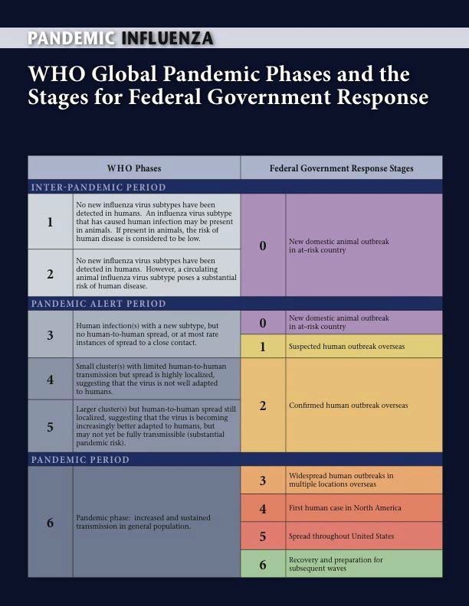
Figure 3-1 Federal Response Stages

3

3 National Strategy for Pandemic Influenza, Implementation Plan, Homeland Security Council, May 2006

Attachment 3 – Pandemic Severity Index/Community Strategies

PANDEMIC SEVERITY INDEX
The CDC has developed a method for classifying the severity of a pandemic in the United States, known as the Pandemic Severity Index (PSI). The PSI tool classifies the impact of a pandemic in five categories. The PSI is used to develop guidelines on community-level measures that could be used during an influenza pandemic to reduce the spread of infection. To help authorities determine the most appropriate actions, the guidelines incorporate a pandemic influenza planning tool for use by states, communities, businesses, schools, and others. It can be difficult for the CDC to accurately depict the severity of an evolving pandemic in real time. The WHO and CDC guidance will be further refined by the local public health authorities to provide guidance that best meets the needs and priorities of the jurisdictions’ population.
Pandemic Severity Index4
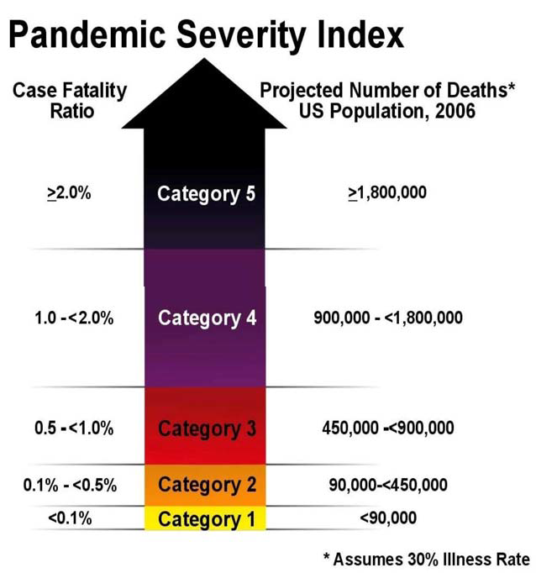

4 “Community Strategy for Pandemic Influenza Mitigation”, Centers for Disease Control and Prevention, Accessed August 19, 2011, http://www.flu.gov/professional/community/commitigation.html#app7 https://www.cdc.gov/media/pdf/MitigationSlides.pdf

Goals of Community Measures
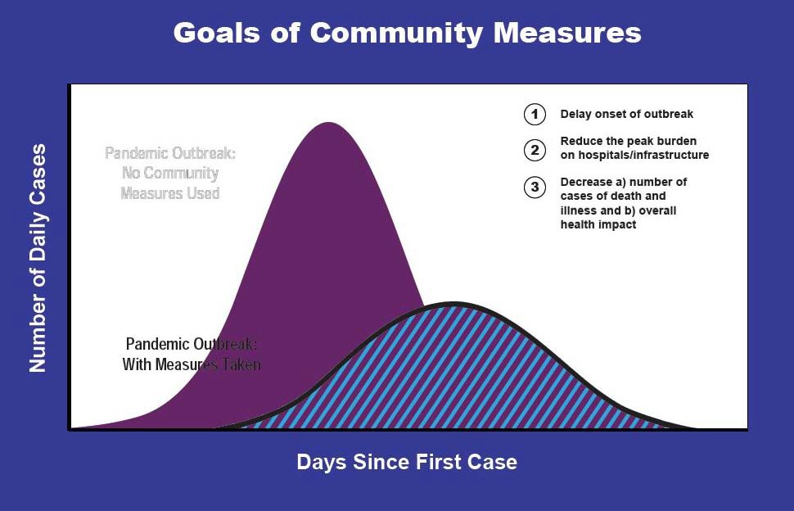
CDC Recommended Interventions by Pandemic Severity Index Categories Home and School
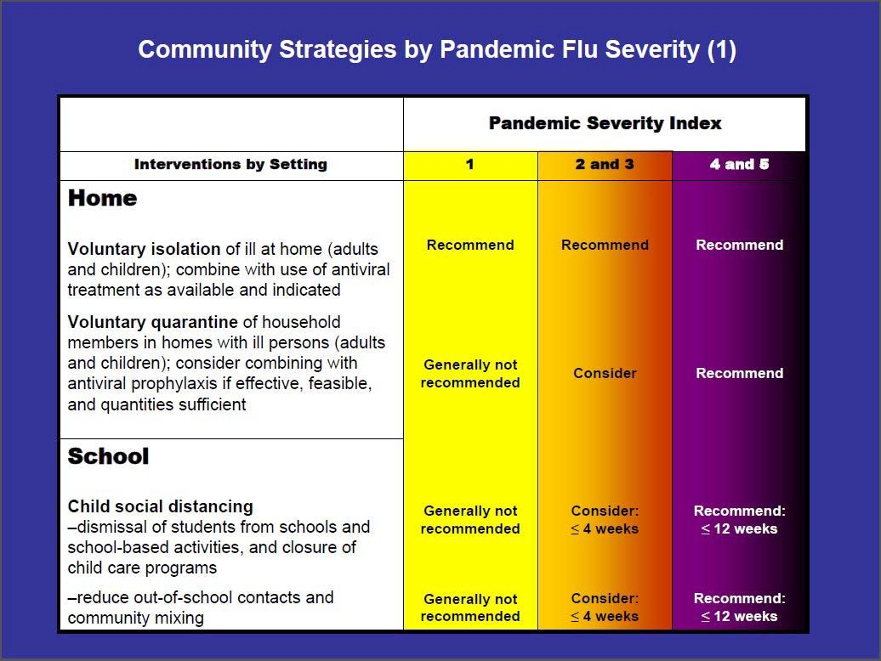

CDC Recommended Interventions by Pandemic Severity Index Categories Workplace/Community
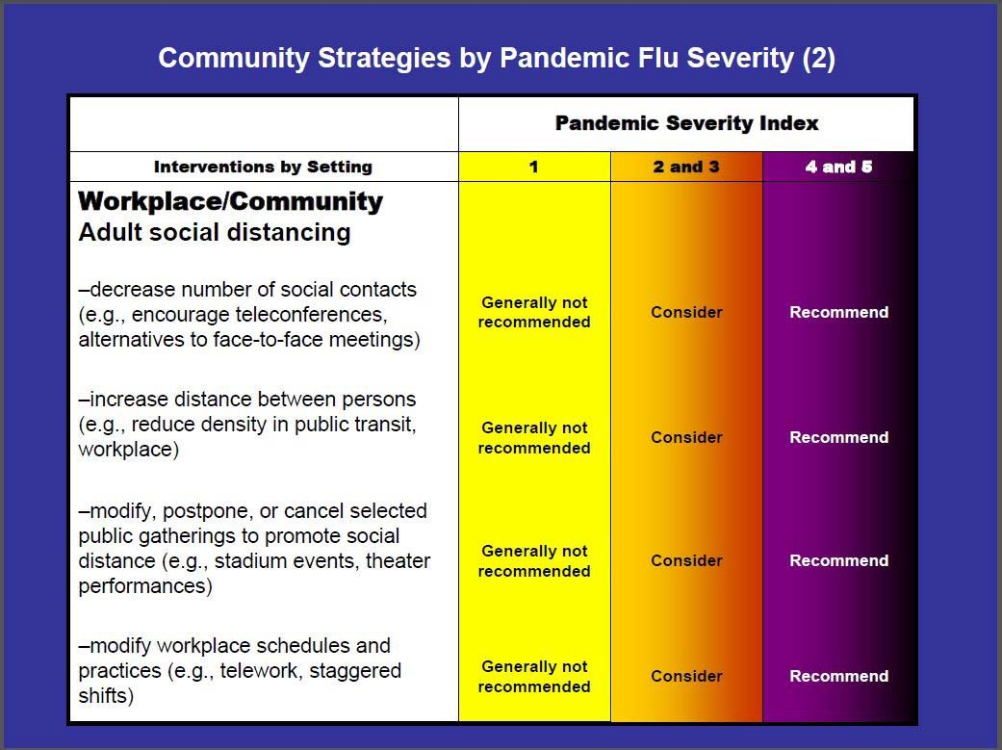

Attachment 4 – Emerging Health Issues Advisory Group

The page has intentionally been left blank

